A

MINI PROJECT REPORT

ON

IMPLEMENTATION OF FSM TO TRAFFIC LIGHT CONTROL

BY  
AUTOMATA - GROUP 15

Department of Science Education

Adekunle Ajasin University, Akungba Akoko,

Ondo State, Nigeria

2019-2020

**CERTIFICATE**

This is to certify that, the project IMPLEMENTATION OF FSM TO TRAFFIC LIGHT CONTROL entitled a bonified record of project work submitted by  
Automata Group 15 (AAUA), in partial fulfillment for our Test , Adekunle Ajasin University, during the year 2019-2020 under my guidance and supervision.

DATE:

GUIDE HEAD OF DEPARTMENT  
 (Dr. Aliyu) (Dr. Ajayi)  
Lecturer in charge Computer Science (H.O.D)

**DEDICATION**

We dedicate this project to …..

**ACKNOWLEDGEMENT**

It is my great pleasure to acknowledge the assistance and contribution of the individuals who co-operated us to complete the project work successfully. First and foremost, We wish to express my deep gratitude and thanks to Dr. Mrs Aliyu Lecturer in-charge of CSC 313 (Automata theory and Formal Language) and our project guide Dr. Ajayi, for their enthusiastic guidance and helping in successful completion of project work. They provided us their precious time for valuable suggestions and encouragement throughout the work. It is for their patience, guidance and encouragement at all time that this work has shaped up the way it is.  
A project is teamwork and reflects the contribution of many people. A number people contributed their time and efforts in making their project work a success. We would like to thank everyone who contributed their time and efforts to help in  
completing the project work.  
  
~~There are 8-lanes and at most two ways can be safely open. In  
this way a minimum of 4-states are possible for which different  
vehicles will pass through~~

**ABSTRACT***:*

Traffic congestion is the biggest problem faced by densely populated countries like Nigeria, United State of America, South Korea, Saudi Arabia, India, China etc. So,  
our project focus on Traffic density control. The project is a replica of a four way lane crossing of real time scenario.

**KEYWORDS***:* Traffic density control, ~~RFID, IR transmitter and receiver, dynamic traffic control.~~

**TABLE OF CONTENT**

**TITLE PAGE - 1**

**APPROVAL PAGE - 2**

**DEDICATION - 3**

**ACKNOWLEDGMENT - 4**

**ABSTRACT - 5**

**INTRODUCTION - 7**

**INTRODUCTION**

Traffic Lights or Traffic Signals are signaling devices that are used to control the flow of traffic.  
Generally, they are positioned at junctions, intersections, ‘X’ roads, pedestrian crossings etc. and alternate the priority of who has to wait and who has to go.  
The traffic lights will provide instructions to the users (drivers and pedestrians) by displaying lights of standard color. The three colors used in traffic lights are Red, Yellow and Green.  
The system must be used to control the traffic lights for smooth and safe movement of traffic.  
These control systems consists of electro mechanical controllers with clockwork mechanisms or modern solid state computerised systems with easy setup and maintenance.

In this project, a FSM based Traffic Light Controller system is designed. It is a simple implementation of traffic lights system but can be extended to a real time system with programmable timings, pedestrian lighting etc.  
Traffic congestion is a severe problem in many major cities across the world and it has become a nightmare for the commuters in these cities. The Traffic congestion can also be caused by large Red light delays, etc. The delay of respective light is hard coded in the traffic light and it is not dependent on traffic. Therefore for simulating and optimizing traffic control to better accommodate this increasing demand is arises .One of the major problems faced by heavy traffic is by ambulances. As we all know that Ambulances are the most important medical means of transport in any country as they carry patients to the nearby hospitals. But due to heavy traffic, one can often see the Ambulances stuck in traffic for long durations thus causing danger to patient’s life.

**TRAFFIC LIGHT CONTROLLER**  
The controller to be designed controls the traffic lights of a busy highway (HWY) intersecting a side road (SRD) that has relatively lighter traffic load. The image below shows the location of the traffic lights. Sensors at the intersection detect the presence of cars on the highway and side road. The figure implies that both the highway and side roads offer single lanes for traffic in each direction.

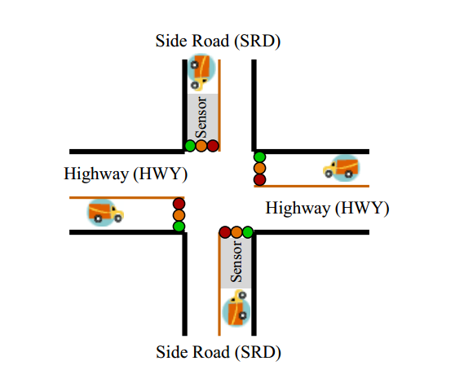

A busy highway is intersected by a little used farm road Detectors C sense the presence of cars on the farm road. With no car on farm road, lights remain Green in highway direction.  
 If vehicle on farm road, highway lights go from Green to Yellow to Red, allowing the farm road lights to become Green, these stay Green only as long as a farm road car is detected but never longer than a set interval (say, 20 time units). When these are met, farm lights transition from Green to Yellow to Red, allowing highway to return to Green Even if farm road vehicles are waiting, highway gets at least a set interval as Green (say, 20 time units)

**INPUTS AND OUTPUTS**  
 Inputs Outputs  
 Reset HG (highway green)  
 C (farm road car detector) HY (highway yellow)  
 HR (highway red)  
 FG (farm road green)  
 FY (farm road yellow)  
 FR (farm road red)  
 **STATES**  
 Color of the lights  
 HG (highway green)  
 HY (highway yellow)  
 HR (highway red)  
 FG (farm road green)  
 FY (farm road yellow)  
 FR (farm road red)

**REDUNDANCY**  
 If the highway light is green or yellow, the farm road light must be red.  
 States  
 HG (highway green)  
 HY (highway yellow)  
 FG (farm road green)  
 FY (farm road yellow)  
Partial traffic light controller  
 Useful to walk through typical execution sequence  
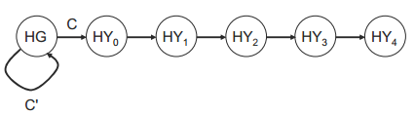

Utilize external timer like a subroutine

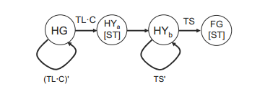

External timer  
- ST resets timer and starts counting  
- Timer generates a short time pulse (TS) and a long time pulse (TL)  
- TS is to be used for timing yellow lights and TL for green lights.

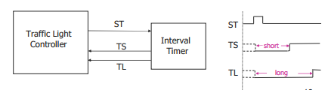

***FSM SPECIFICATION***  
 - **Inputs**  
reset place FSM in initial state  
C detect vehicle on the farm road  
TS short time interval expired  
TL long time interval expired  
- **Outputs**  
HG, HY, HR assert green/yellow/red highway lights  
FG, FY, FR assert green/yellow/red farm road lights  
ST start timing a short or long interval  
- **State**  
HG highway green (farm road red)  
HY highway yellow (farm road red)  
FG farm road green (highway red)  
FY farm road yellow (highway red)

Traffic light controller

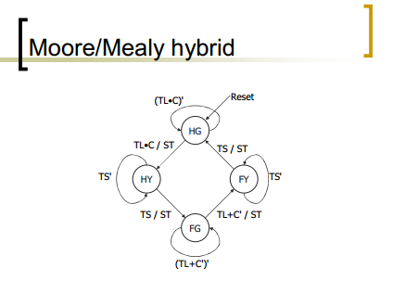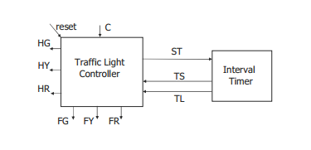

**STATE ENCODING**  
 Let's use a one-hot encoding:  
 HG = 0001  
 HY = 0010  
 FG = 0100  
 FY = 1000

**Next-state logic**  
- P3 = (C'·Q2) + (TL·Q2) + (TS'·Q3)  
- P2 = (TS·Q1) + (C·TL'·Q2)  
- P1 = (C·TL·Q0) + (TS'·Q1)  
- P0 = (C'·Q0) + (TL'·Q0) + (TS·Q3)  
- ST = (C·TL·Q0) + (TS·Q1) + (C'·Q2) + (TL·Q2) + (TS·Q3)  
Outputs  
- Green = 00  
- Yellow = 01  
- Red = 10  
- Two sets of outputs: H1H0 and F1F0  
 H1 = Q3 + Q2  
 H0 = Q1  
 F1 = Q1 + Q0  
 F0 = Q3

**V. ADVANTAGES**

**Advantages of Smart Ambulance System:**  
1. Ambulance service will no longer be affected by traffic jams.  
2. Use of radio frequency signal (not blocked by objects, fast).  
3. Over a wide range applicability.  
4. One time investment cost.  
5. Life of people can be saved.  
**Advantages of Traffic Density Control System:**  
1. A modernized way of controlling traffic.  
2. Number of road accidents can be reduced to a large extent.  
3. Easy traffic regulation in busy cities such as Delhi, Mumbai etc..  
4. Help the traffic police in easy control of traffic

**VI. CONCLUSION**

This Project which demonstrates an automated patient monitoring system has its own merits which are discussed  
above. We have presented some applications of how people could benefit from living in homes that have wireless  
sensor technologies for improving the quality of life. The first decade of research in the field of wearable technology  
was marked by an emphasis on the engineering work needed to develop wearable sensors and systems, recent studies  
have been focused on the application of such technology toward monitoring health and wellness. This consideration  
was the basis for this project review. This project summarized enabling technologies developed over the past decade  
and put a great deal of emphasis on surveying studies focused on the deployment of wearable sensors and systems in  
the context of a concrete clinical applications, with main focus on rehabilitation. This wearable module can transmit the  
data continuously over a fiber optic link or through an internet digital radio. The received data can be stored in separate  
memory and be processed by a microcontroller.

**VII. FUTURE SCOPE**

• This project can be enhanced in such away as to control automatically the signals depending on the traffic density on the roads using sensors like IR detector/receiver module extended with automatic turn off when no vehicles are running on any side of the road which helps in power consumption saving.  
• No. of passing vehicle in the fixed time slot on the road decide the density range of traffics and on the basis of vehicle count microcontroller decide the traffic light delays for next recording interval. In future this system can be used to inform people about different places traffic condition. This can be done through RADIO. Data transfer between the microcontroller and computer can also be done through telephone network, data call activated SIM This technique allows the operator to gather the recorded data from a far end to his home computer without going there  
• Traffic lights can be increased to N number and traffic light control can be done for whole city by sitting on a single place.  
• In ambulance system, the data of the patient in the ambulance can be sent to the Hospitals via GSM technology. Thus, it can provide early and fast treatment of the patient.

**REFERENCES**  
[1]. Legon-Okponglo, “Design and development of microcontroller based traffic system using image processing techniques”. University of Ghana,  
published in ICAST, 2012 *IEEE 4th International Conference.*  
[2]. Amrita Rai and Govind Singh Patel Multiple Traffic Control Using Wireless Sensor and Density Measuring Camera. Sensors & Transducers  
Journal Vol. **94**, Issue 7, July 2008, pp. 126-132.  
[3]. Muhammad Ridwan. “Development of a Low Cost Smart Traffic Controller System”. Department of Mechanical and Materials Engineering  
Faculty of Engineering and Built Environment University Kebangsaan Malaysia, 43600 Bangi Selangor, Malaysia.  
[4]. “Highway traffic model-based density estimation”-IEEE paper by Morarescu, Nancy Univ., France, published in American Control  
Conference(ACC), 2011.  
[5]. W. Wen & C.L. Yang. “A dynamic and automatic traffic light control system for solving the road congestion problem”.  
[6]. “Iterative learning based Freeway density control”-IEEE paper by Jianye Li, Wuyi Univ.,China, published in Information Engineering and  
Computer Science(IECS),2nd International Conference  
[7].http://www.edgefxkits.in/embedded/pic/density-based-traffic-signal-system-using-picmicrocontroller.  
[8].http://www.ijater.com/Files/IJATsER_03_06.pdf  
[9] Muhammad Ridwan. “Development of a Low Cost Smart Traffic Controller System”. Department of Mechanical and Materials Engineering  
Faculty of Engineering and Built Environment University Kebangsaan Malaysia, 43600 Bangi Selangor, Malaysia.  
[10] Marco Wiering. “Intelligent Traffic Light Control”. Institute of information and computing sciences, Utrecht University.  
[11] “Automatic Traffic Control System”. SMEU Astana Solutions Automatic Traffic Control System.htmKarmakar, N. , Handbook of Smart  
Antennas for RFID Systems ,Wiley-IEEE Press, Pages: 13 -56 .  
[12] PIC16F877A, 8 bit PIC microcontroller, http://www.microchip